ABIRAMI K

230701008 CSE-A

EXP NO: 12

FILE ORGANIZATION TECHNIQUE SINGLE AND TWO LEVEL DIRECTORY

PROGRAM

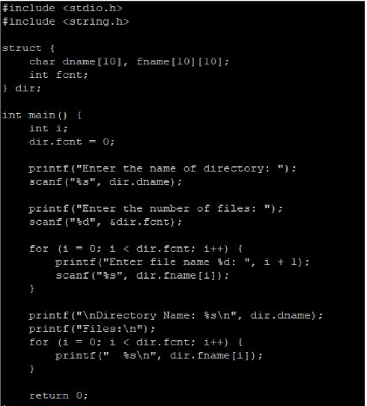

OUTPUT

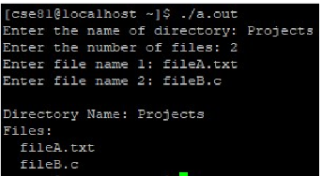

PROGRAM

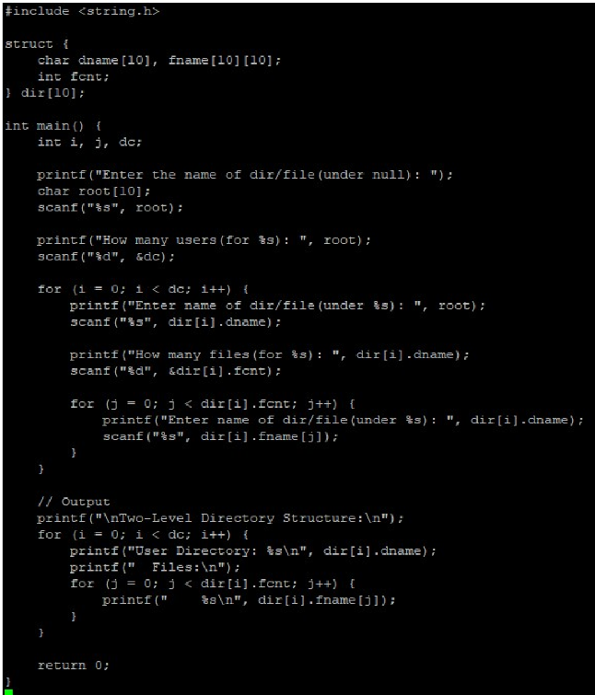

OUTPUT

